

Assignment # 2

Secure Chat System

Presented to

Sir Aadil Ur Rehman

In partial fulfillment
of the requirements for the course of

Information Security

By:

Areen Zainab

(22i - 1115)

Section H

GitHub Repository: https://github.com/Areen-Zainab/securechat-skeleton

TESTING AND VALIDATION
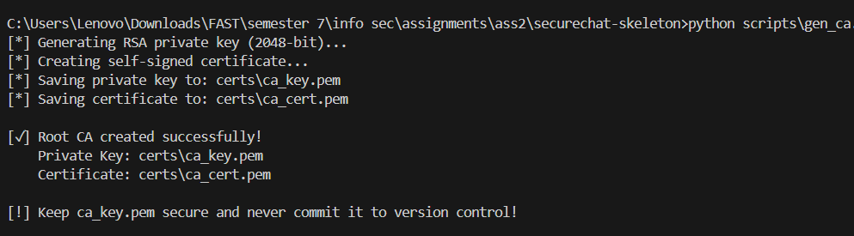
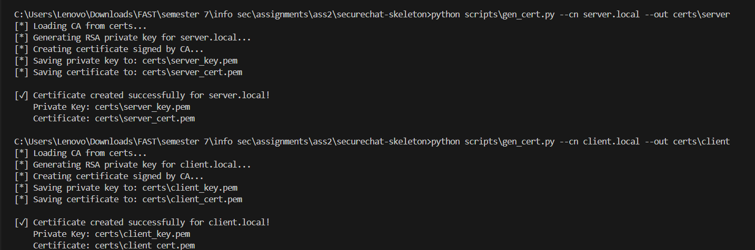

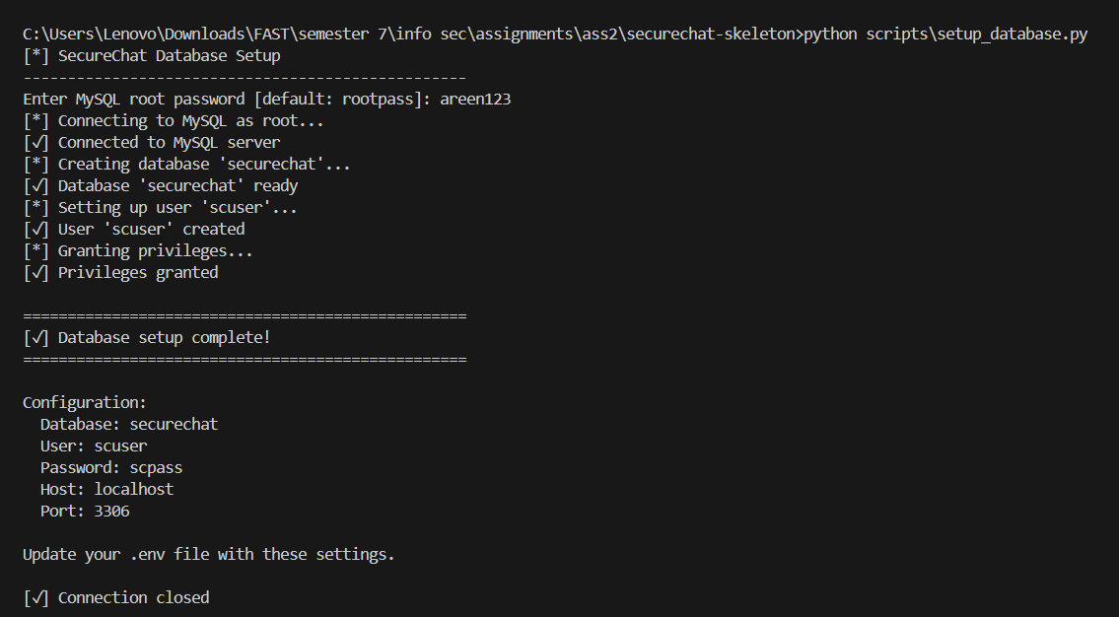

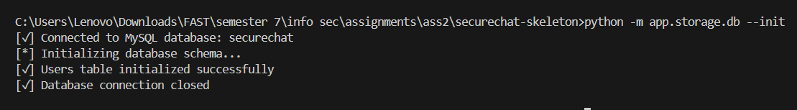
client:
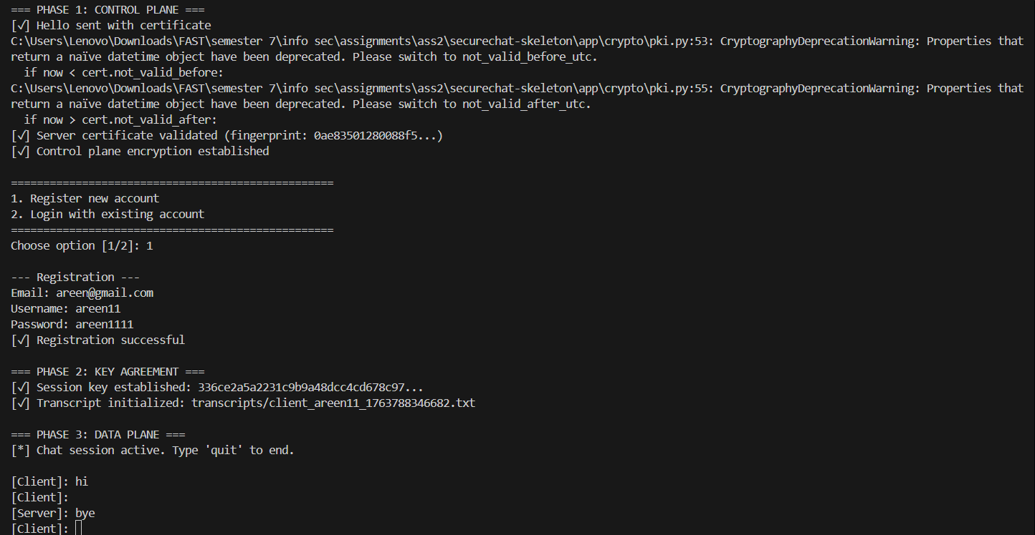
server:
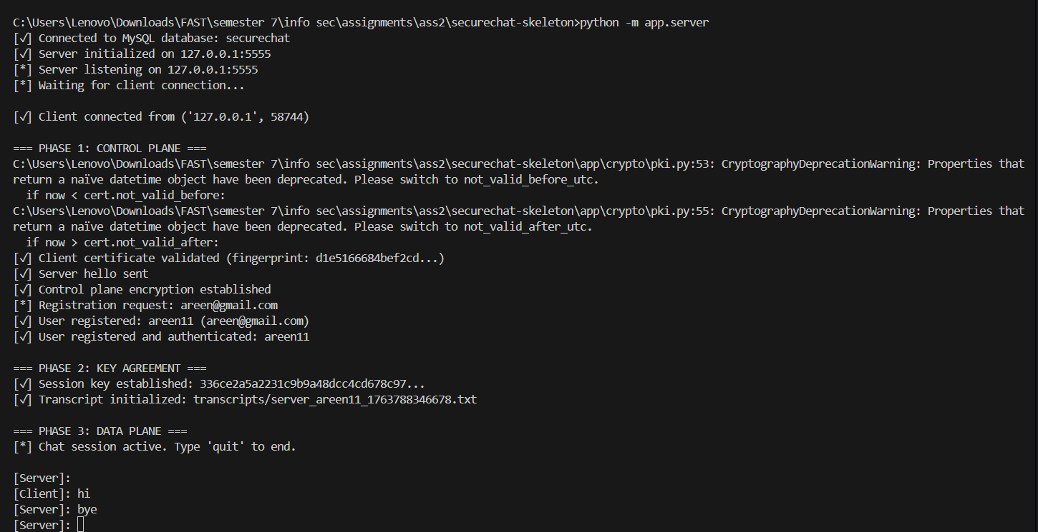

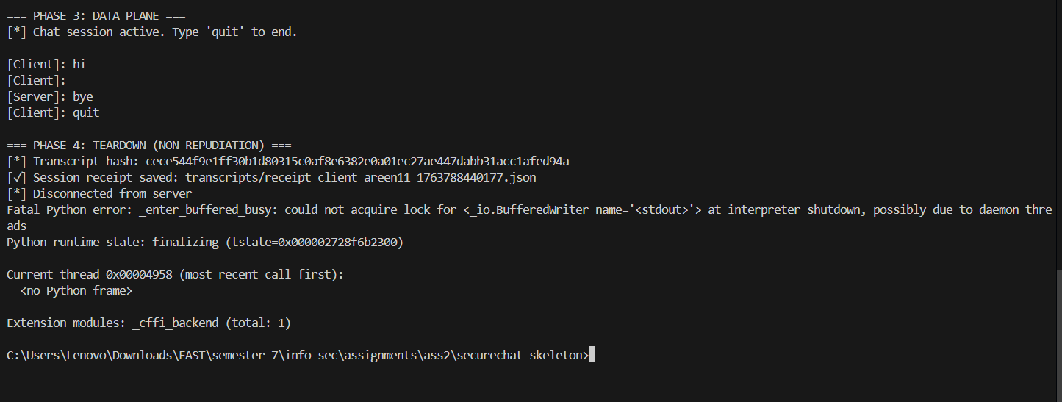
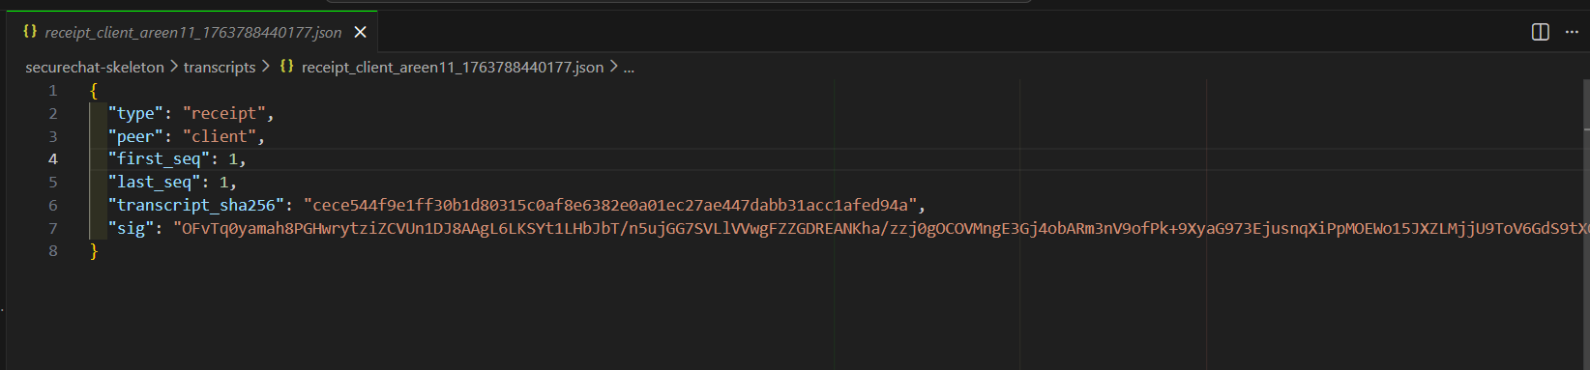

TEST 1: Wireshark - Encrypted Payloads:
Wireshark was used to confirm that no plaintext communication occurs during registration, login, or chat. A filter was applied: tcp.port == 900 All observed packets contained only encrypted ciphertext (AES-128). The transcript contained Base64-encoded ciphertext with no readable content.

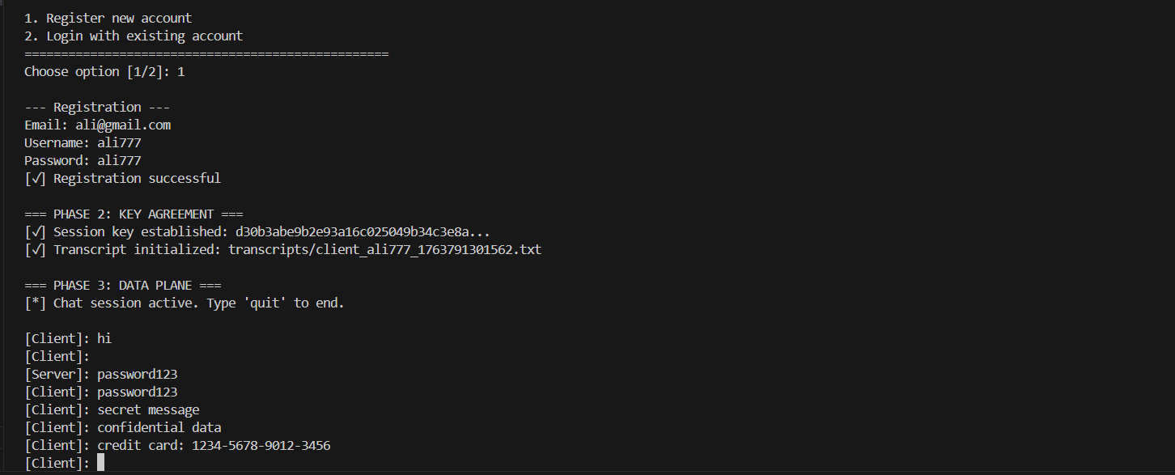

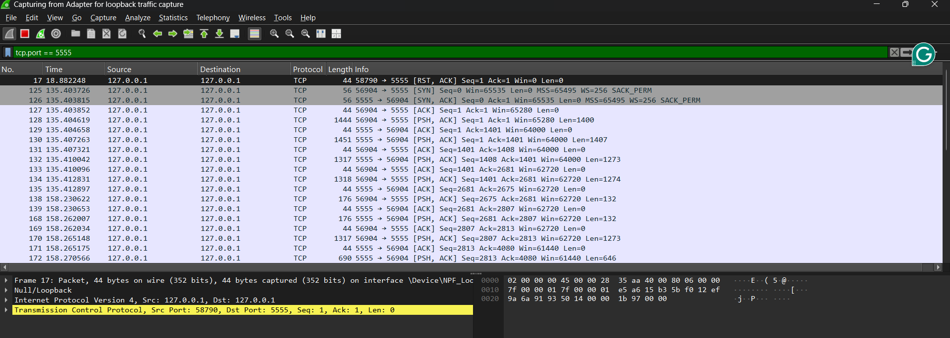
tcp.port == 5555 && frame contains "password" show **0 packets** (message encrypted)
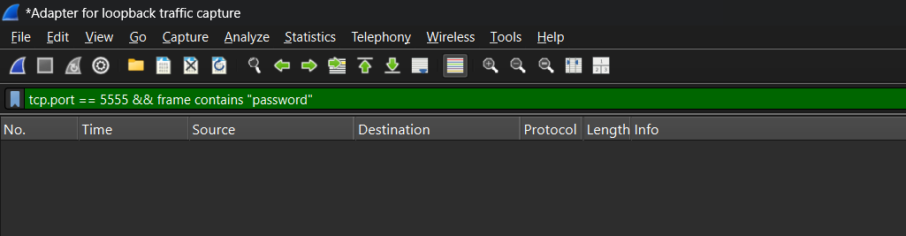
This screenshot verifies that sensitive data such as passwords and confidential messages never appear in plaintext on the network. Using the Wireshark filter frame contains "password", the capture shows "0 packets" matching the search term, despite the client having transmitted login credentials during the session. Similar searches for message keywords like "secret" or "confidential" also return zero results.

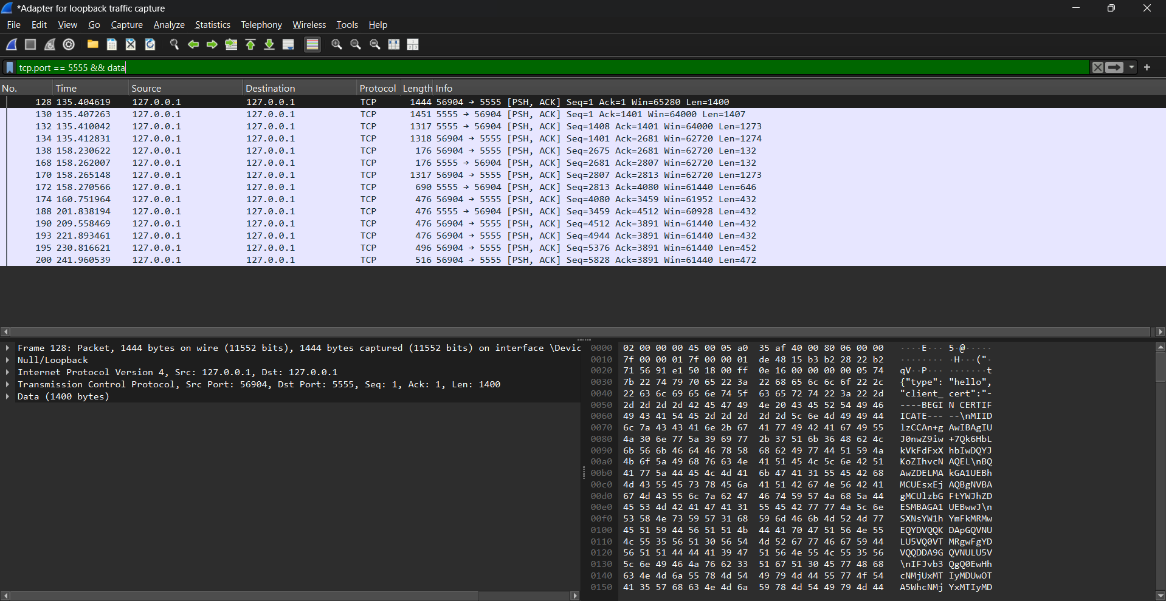

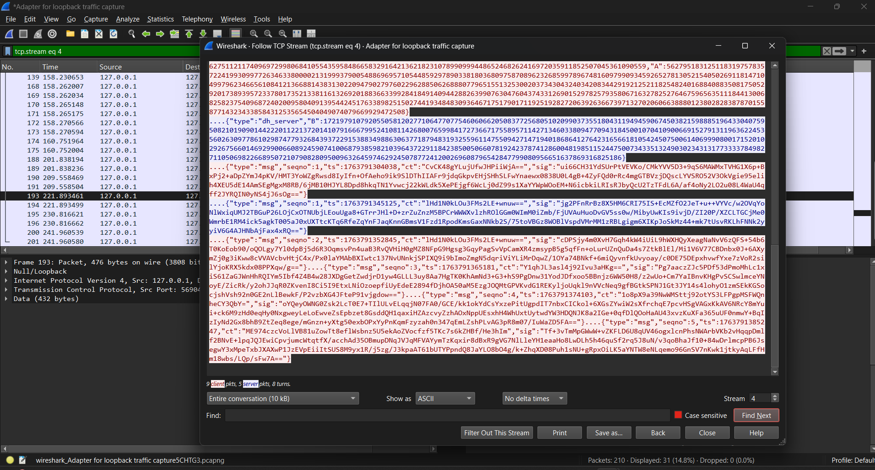

TEST 2: Invalid Certificate Test

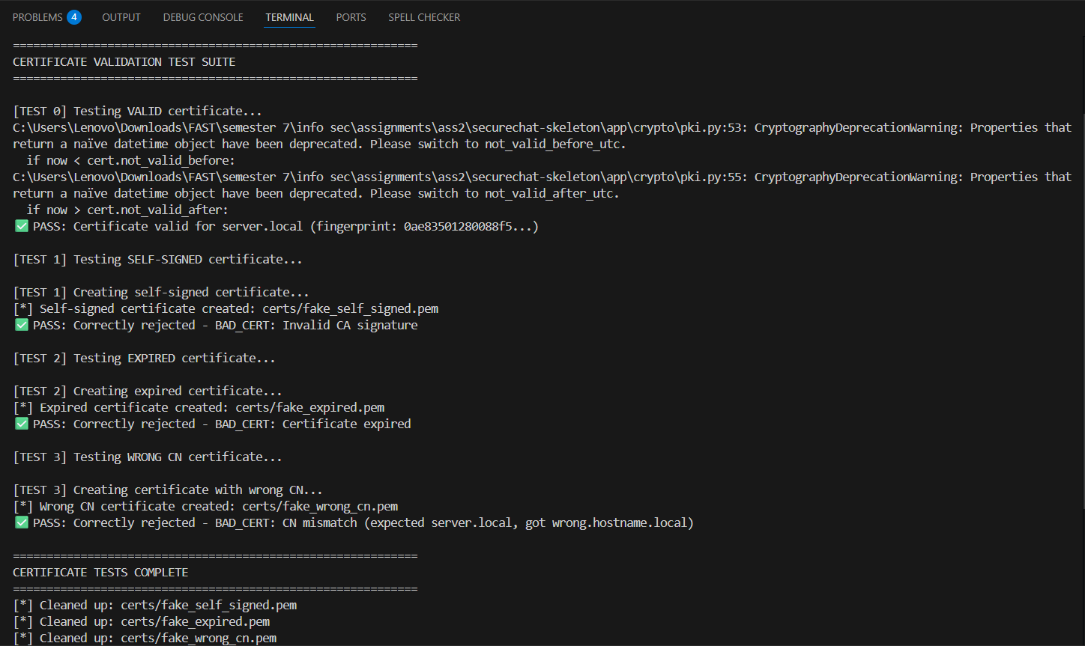

TEST 3: Message Tampering Test
This test demonstrates the integrity protection mechanism detecting message tampering in real-time. After deliberately flipping bits in an encrypted message's ciphertext field, the receiving party's signature verification fails with a "SIG_FAIL: Invalid signature" error. The system correctly identifies that the RSA signature no longer matches the recomputed SHA-256 digest of the tampered data, proving that the message was modified in transit. This test confirms that even a single-bit change in the sequence number, timestamp, or ciphertext renders the digital signature invalid, providing strong integrity guarantees and preventing undetected message manipulation.

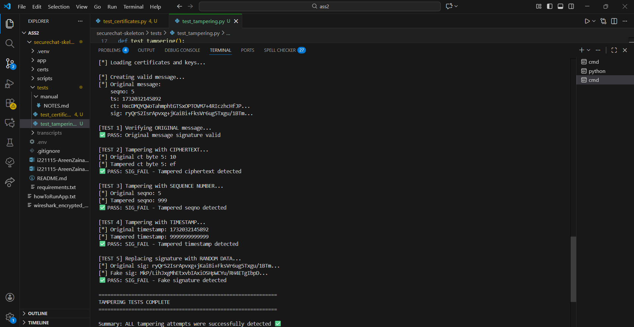

TEST 4: Replay Attack Test
This test shows the replay protection mechanism successfully rejecting a previously transmitted message. When an attacker attempts to resend message with sequence number 5 after the receiver has already processed it, the system immediately detects the violation and responds with "REPLAY detected: seqno 5" error. The strictly increasing sequence number validation ensures that old messages cannot be replayed to confuse the system or cause duplicate processing. This protection remains effective even if the replayed message has a valid signature, as the sequence number enforcement operates independently of cryptographic verification to provide defense-in-depth against replay attacks.
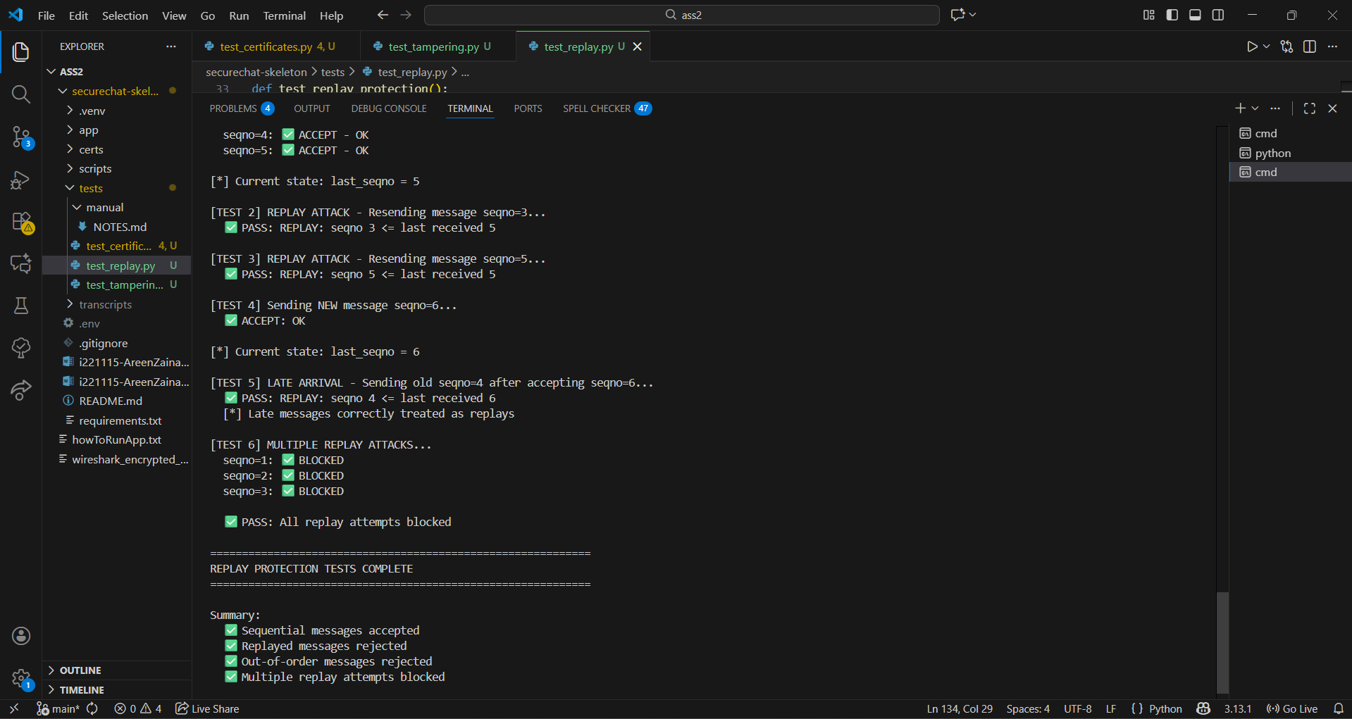

TEST 5: Non-Repudiation - Offline Verification
This screenshot demonstrates the complete non-repudiation workflow through offline verification of session receipts. The first part shows successful verification where the receipt's RSA signature validates correctly against the transcript hash, proving the sender's participation in the conversation. The second part shows the same verification failing after manually editing one transcript entry, where the recomputed hash no longer matches the signed value in the receipt. This tamper-evident property ensures that any modification to the session transcript—whether changing a single character or deleting entire messages—is immediately detectable during verification. The cryptographic binding between the transcript content and the signed receipt provides irrefutable proof of communication that can be verified by any third party with access to the participant's certificate, establishing legal-grade non-repudiation for dispute resolution.
